YOUTH ENTREPRENEURSHIP ECOSYSTEM

Young Entrepreneur Institute believes every child should understand and experience entrepreneurship. Young Entrepreneur Institute helps schools, community organizations and the northeast Ohio business community work together to develop and deliver programs that continuously strengthen entrepreneurial education and entrepreneurship experiences for young people.

(Pic Deb Hoover or video clip?)
“Northeast Ohio has one of the strongest entrepreneurship education ecosystems in the world and Young Entrepreneur Institute is a really critical part of all of that, impacting thousands of students and teachers every year”

- Deborah Hoover, President and CEO of the Burton D. Morgan Foundation.

(Pic Greg Malkin or video clip)_
That impact is achieved through collaborating with teachers, educators and entrepreneurs to teach best practices to as many children as possible.

- Greg Malkin, Executive Director, Young Entrepreneur Institute

After School and Out of School

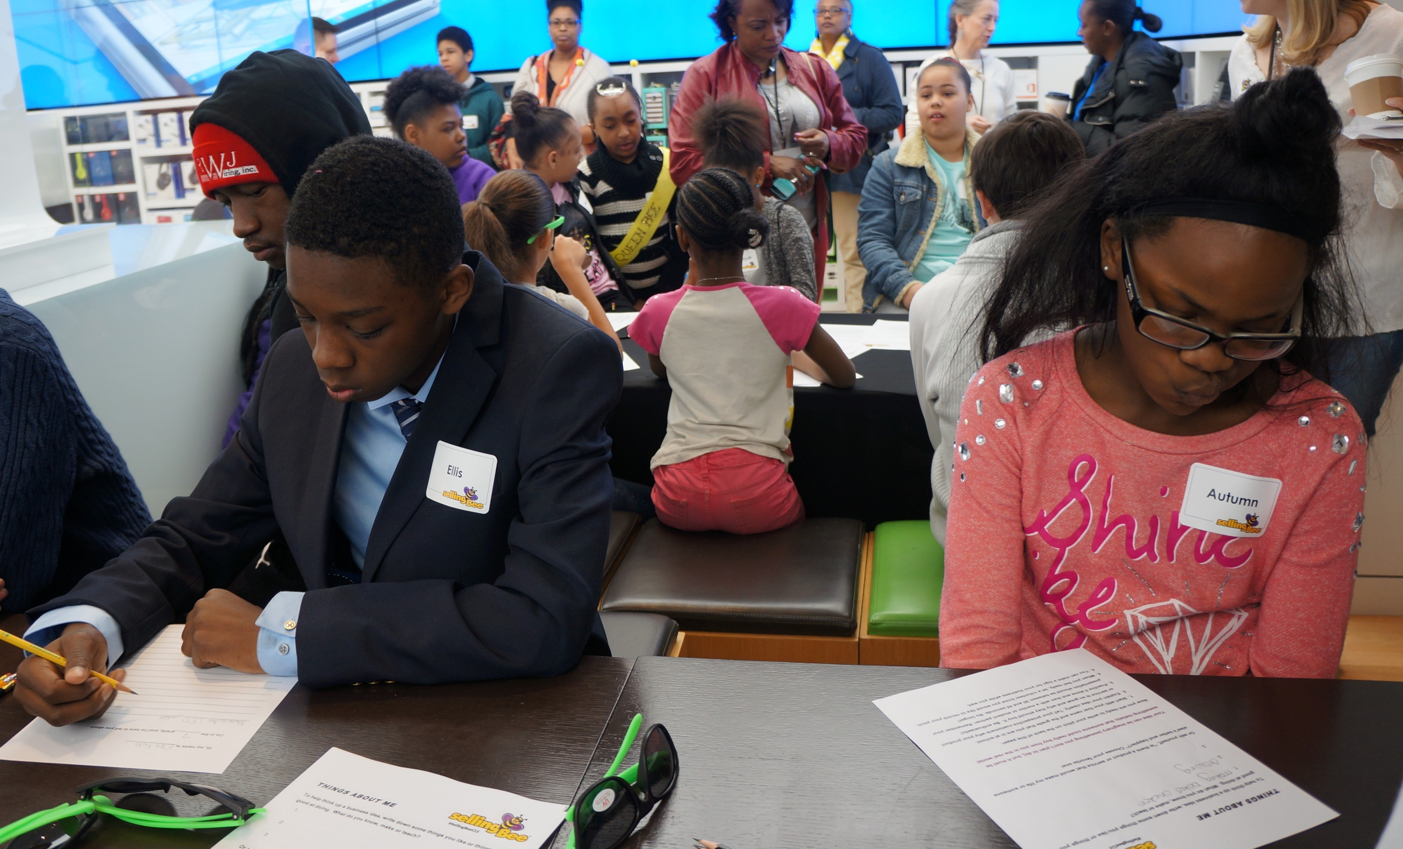

Experiential entrepreneurship education is fun and is the perfect complement to what is being taught in school, without feeling like school at all! Whether it’s learning about profit and loss with our Lemonade Day curriculum, presenting that first business idea, or speaking to potential customers at a farmer’s market – Young Entrepreneur Institute can help you choose curriculum that best suits your group of children. We provide engaging experiences that inspire children to explore entrepreneurship. The life skills taught in after school and out of school programs can instill the confidence to succeed in life—whether or not one decides to become an entrepreneur.
Young Entrepreneur Institute has worked with programs such as Boys and Girls Clubs, Save Our Children, Girl Scouts, Consortium for African American Organizations, Slavic Village P-16, Central Promise Neighborhood and many more. Many of these organizations have a adopted a “whole” child view, supporting children with primary needs while also providing enrichment programming. Our goal is to work together to support children in becoming productive and caring citizens.

Schools

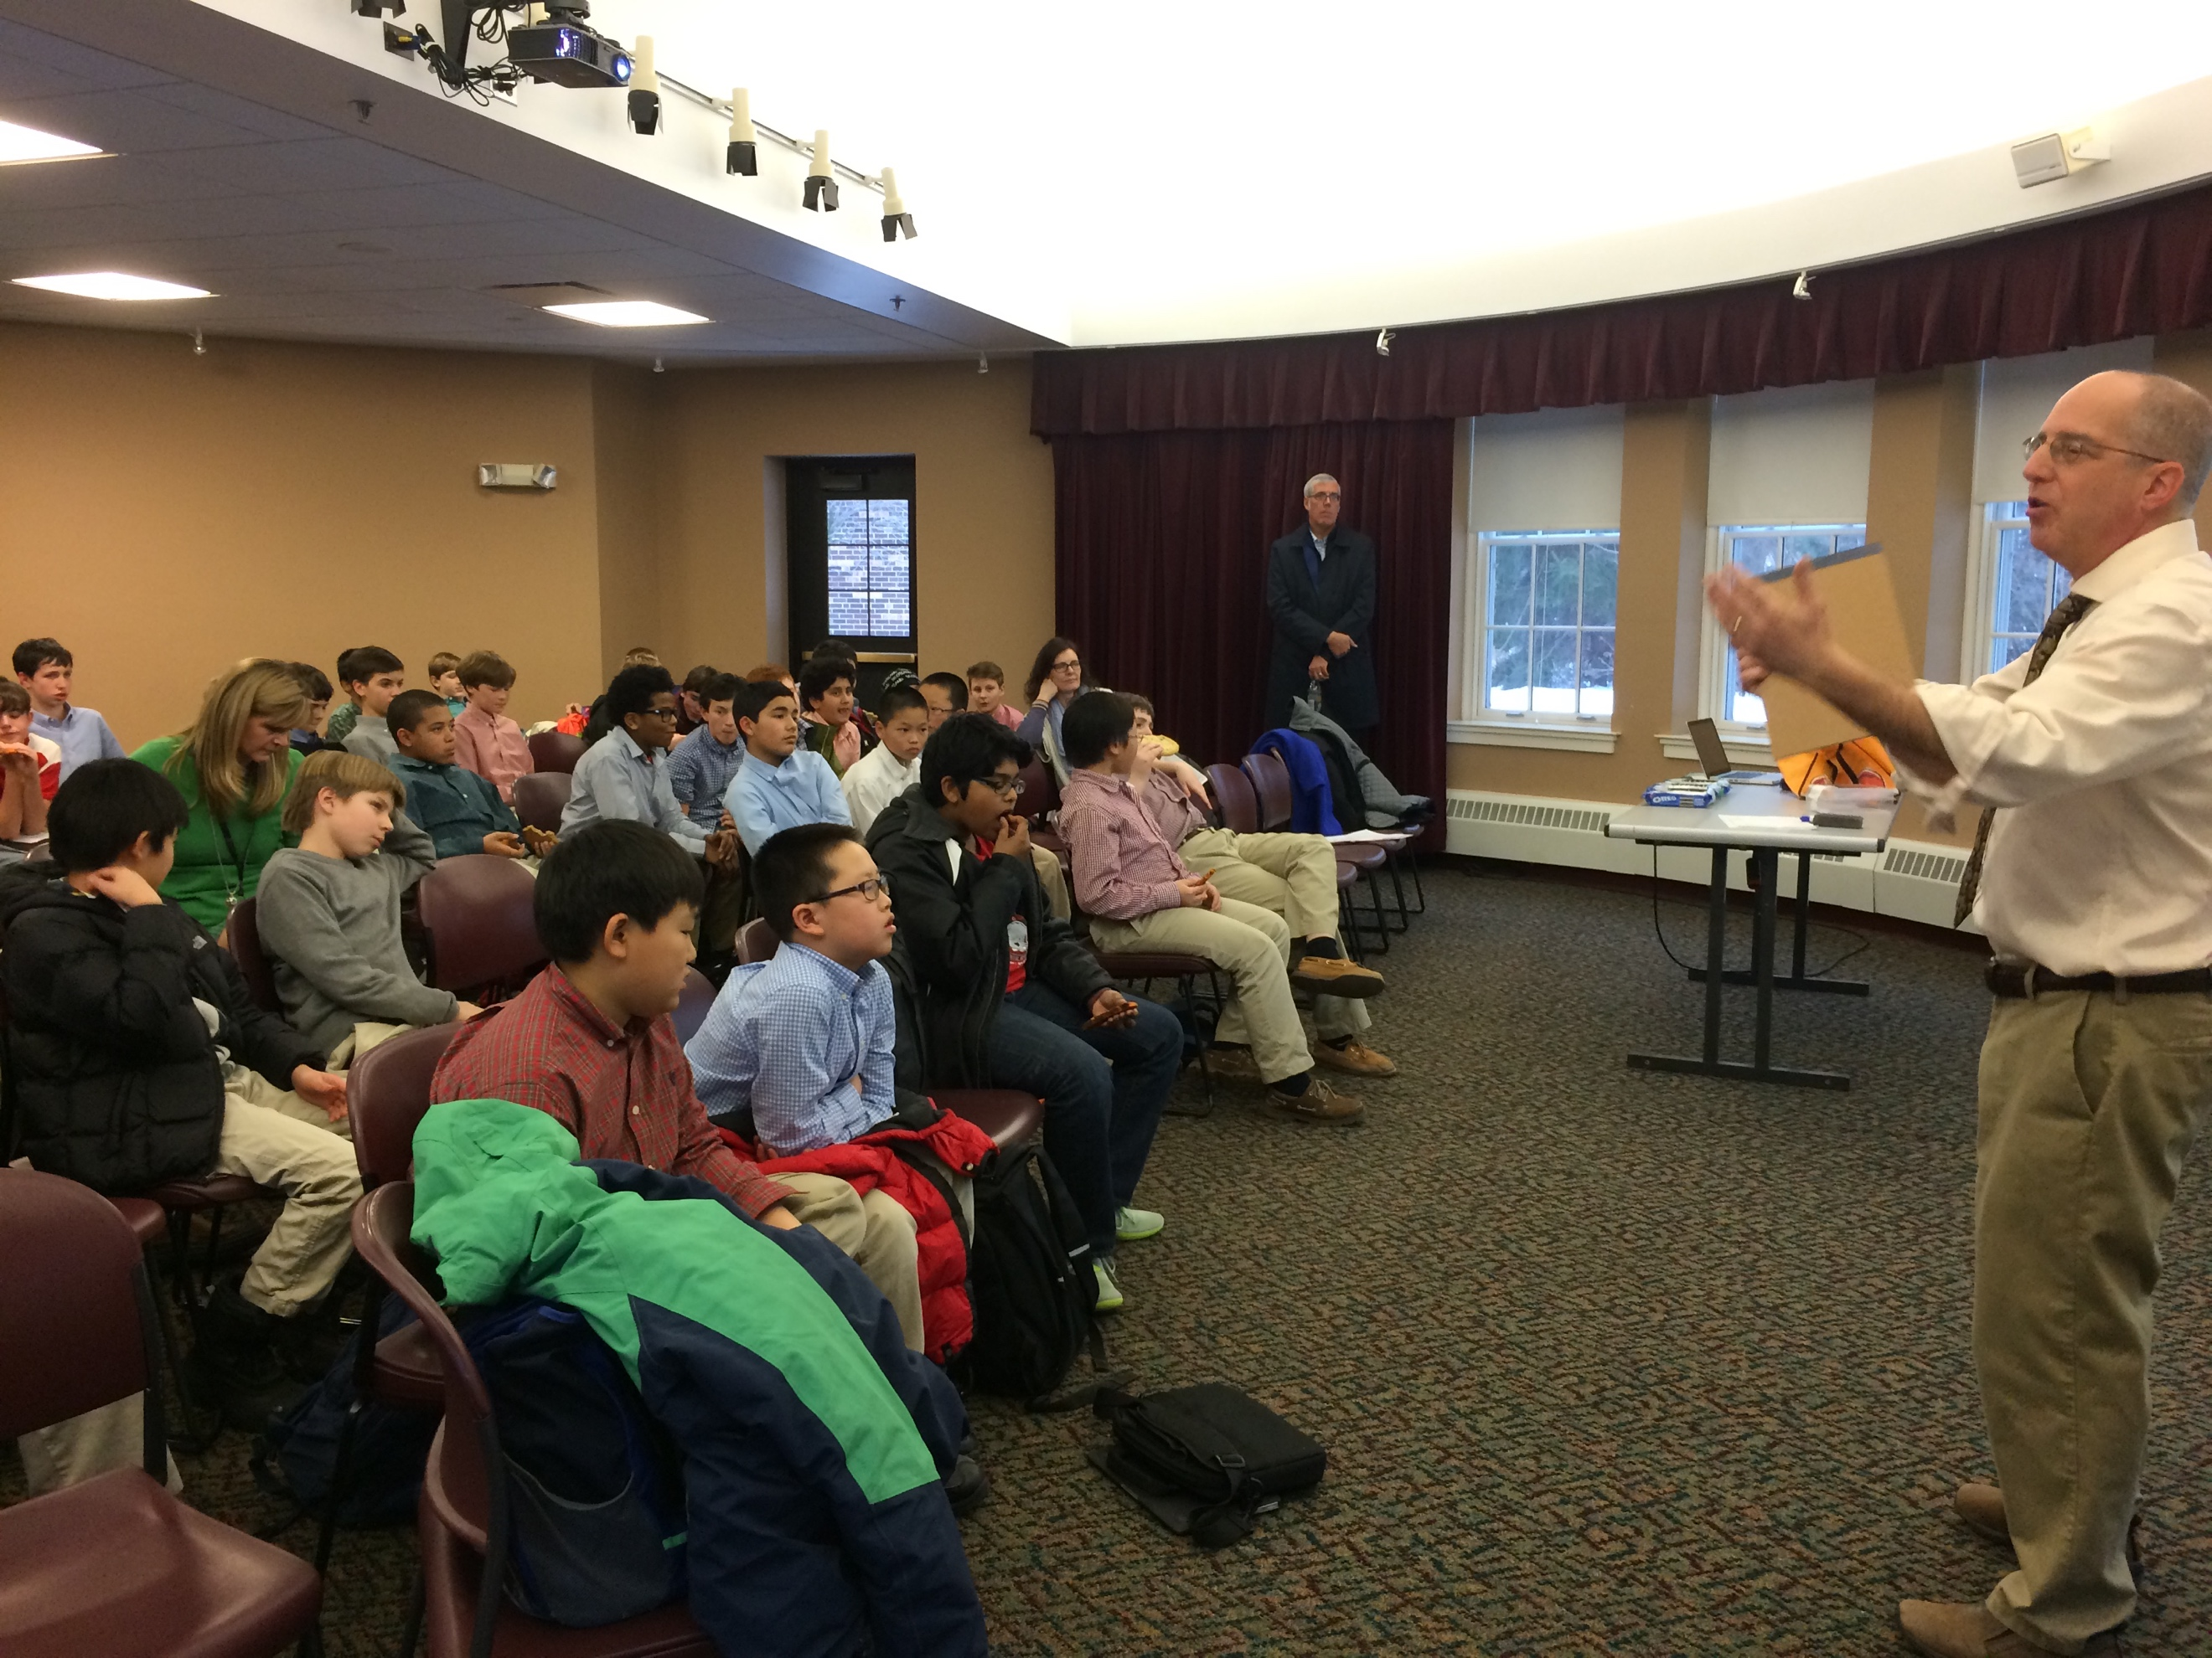

We love our teachers—they are the key to our success! Young Entrepreneur Institute has partnered with hundreds of schools and has impacted thousands of children across Northeast Ohio and beyond since 2005. Young Entrepreneur Institute is highly collaborative, promoting networking events to learn and share best practices. Free educator retreats are hosted on a bi-monthly basis, providing turn-key curriculum that can be taught the next day! Free classroom visits are also available year-round with YEI staff on hand to ignite the entrepreneurial mindset and teach the fundamentals of the elevator pitch. Our year culminates with the Enspire Conference—YEI’s opportunity to introduce teachers and program providers to the most current entrepreneurship curriculum and educational tools available.

Content Providers

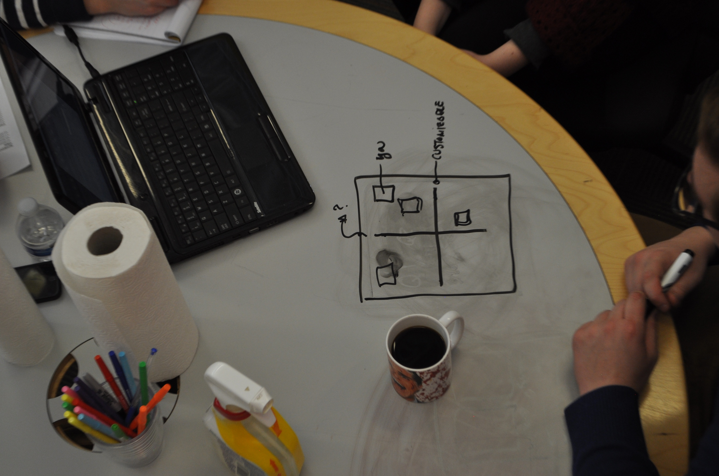

Young Entrepreneur Institute (YEI) is highly collaborative and impacts thousands of students every year in partnership with a vast network of content providers who share our passion to provide experiential entrepreneurship education. YEI is focused on connecting educators with their “best fit” curriculum—even if it’s not one of our programs! At our November Enspire Conference for educators, Young Entrepreneur Institute organized over 30 content providers to provide mini grants for a wide range of entrepreneurship programming. We see our role in the ecosystem as entrepreneurship education evangelists. Facilitating connections between our educators and partners is the key to our success.

Friends of Youth Entrepreneurship

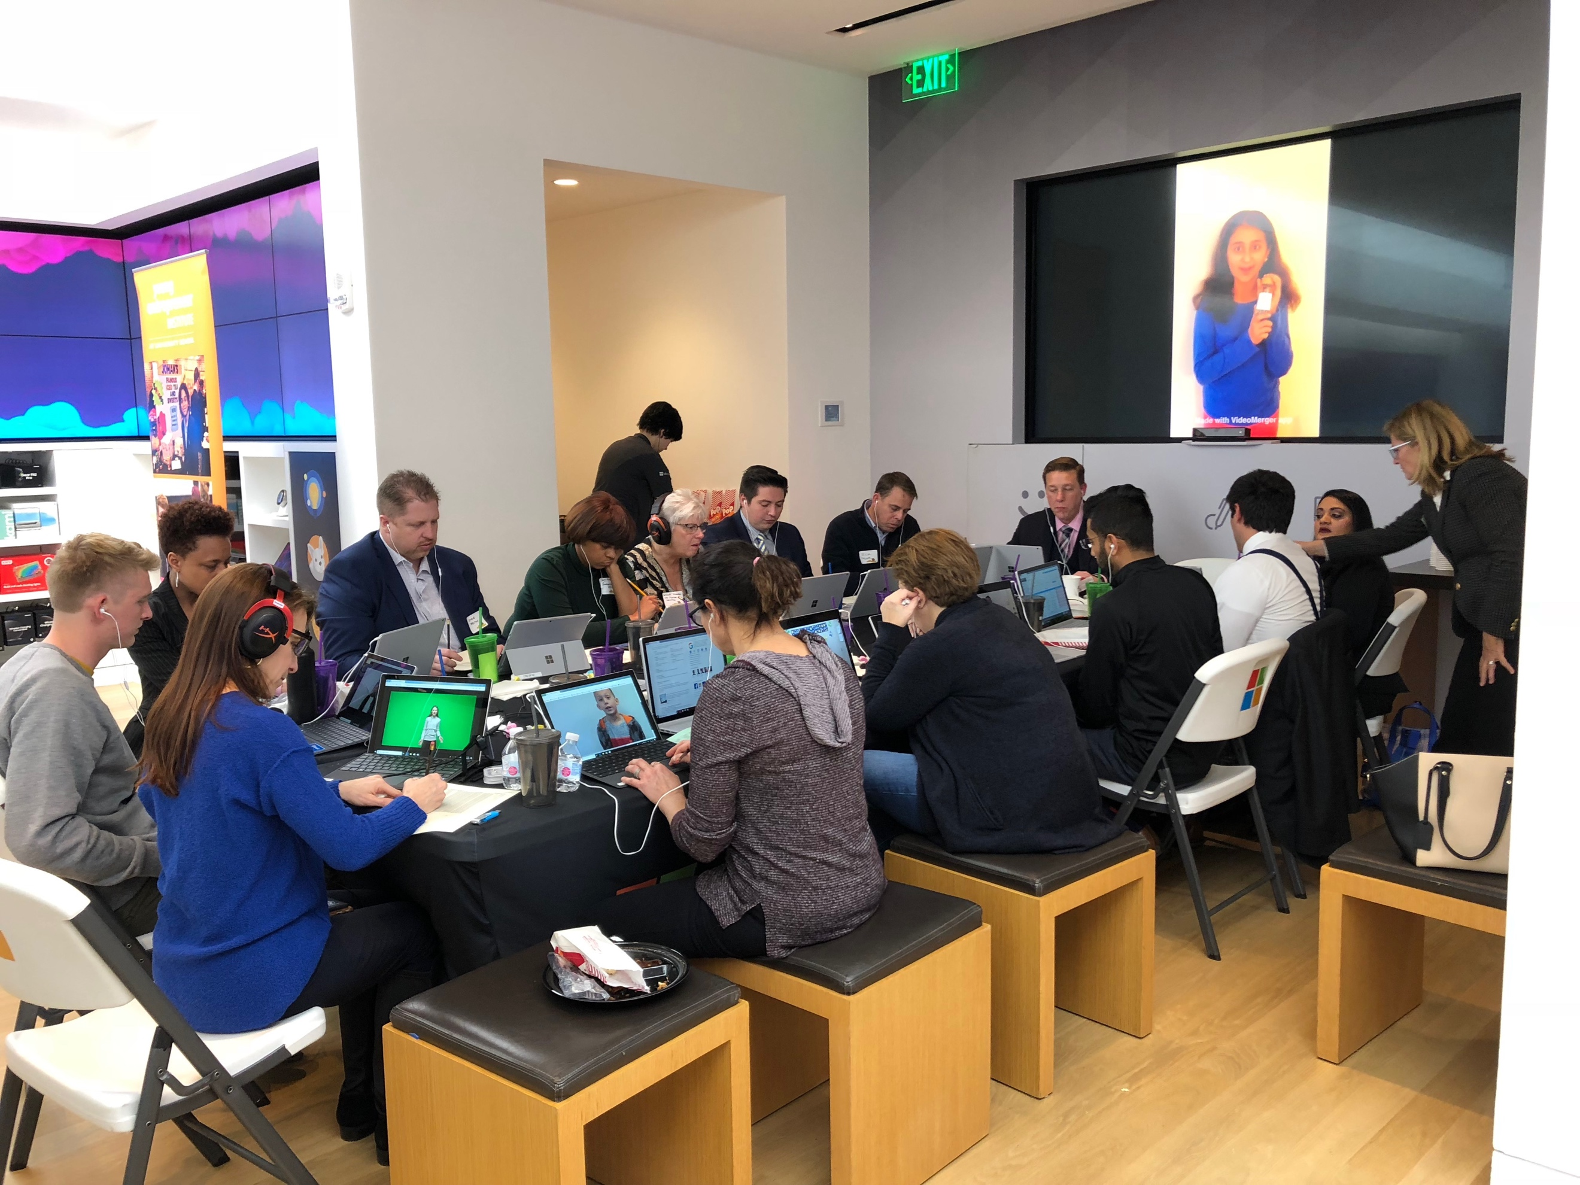

Young Entrepreneur Institute is fortunate to have a passionate and growing community of supporters who champion our work. Our “Friends of Youth Entrepreneurship” represent a diverse group of business owners, young professionals and chambers of commerce members who lend their expertise and donate their time to support youth entrepreneurship both in and out of the classroom. Our team has been on hand to mentor and speak to students, coach business presentations, judge elevator pitch contests, and offer their skills in marketing, law and fundraising. If you are passionate about youth entrepreneurship and want to join our team, click here.

Community Partners

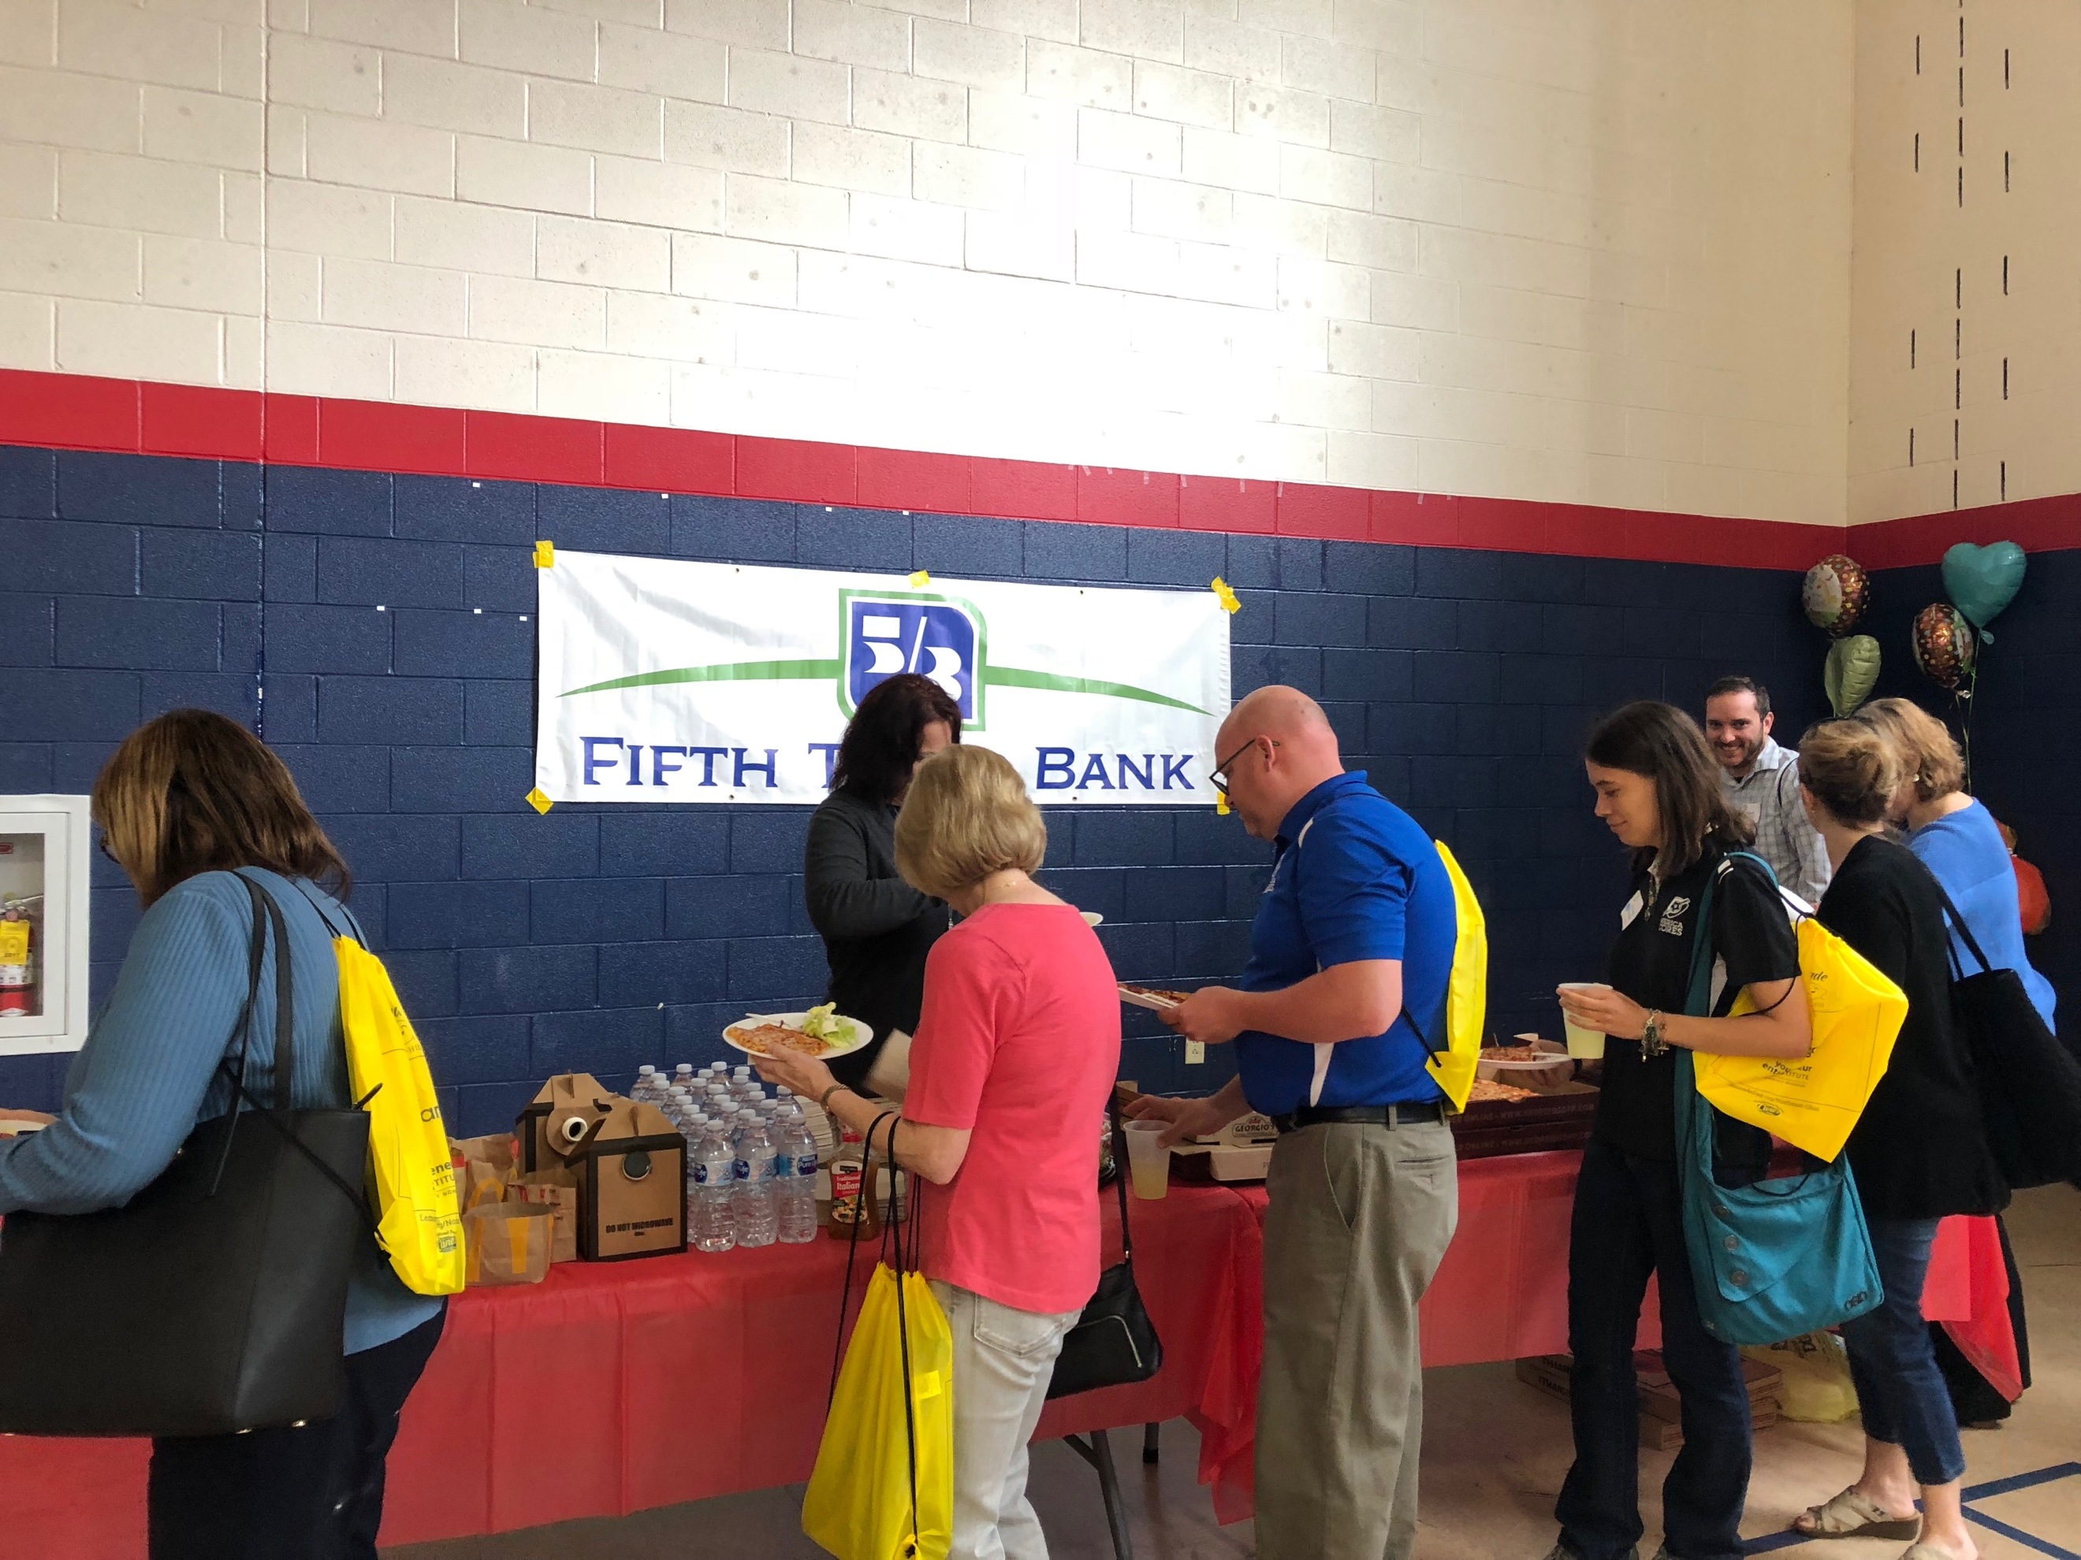

Youth Entrepreneurship is strongly supported by a host of foundations, higher education institutions, entrepreneurship organizations and civic-minded companies. They believe, as we do, that entrepreneurship education and fostering the next generation of brilliant minds is key to developing our local economy. Our community partners provide the critical funding that supports YEI programming, but also dedicates their personal time consulting and volunteering in the field. YEI is fortunate to have the support of the Burton D. Morgan Foundation, Mott Foundation, Nordson Corporation, Veale Foundation, TJ Maxx Foundation, Fifth Third Bank, PNC Bank, Merrill Lynch and others. Click here for a full list of our community partners.

Young Entrepreneur Institute
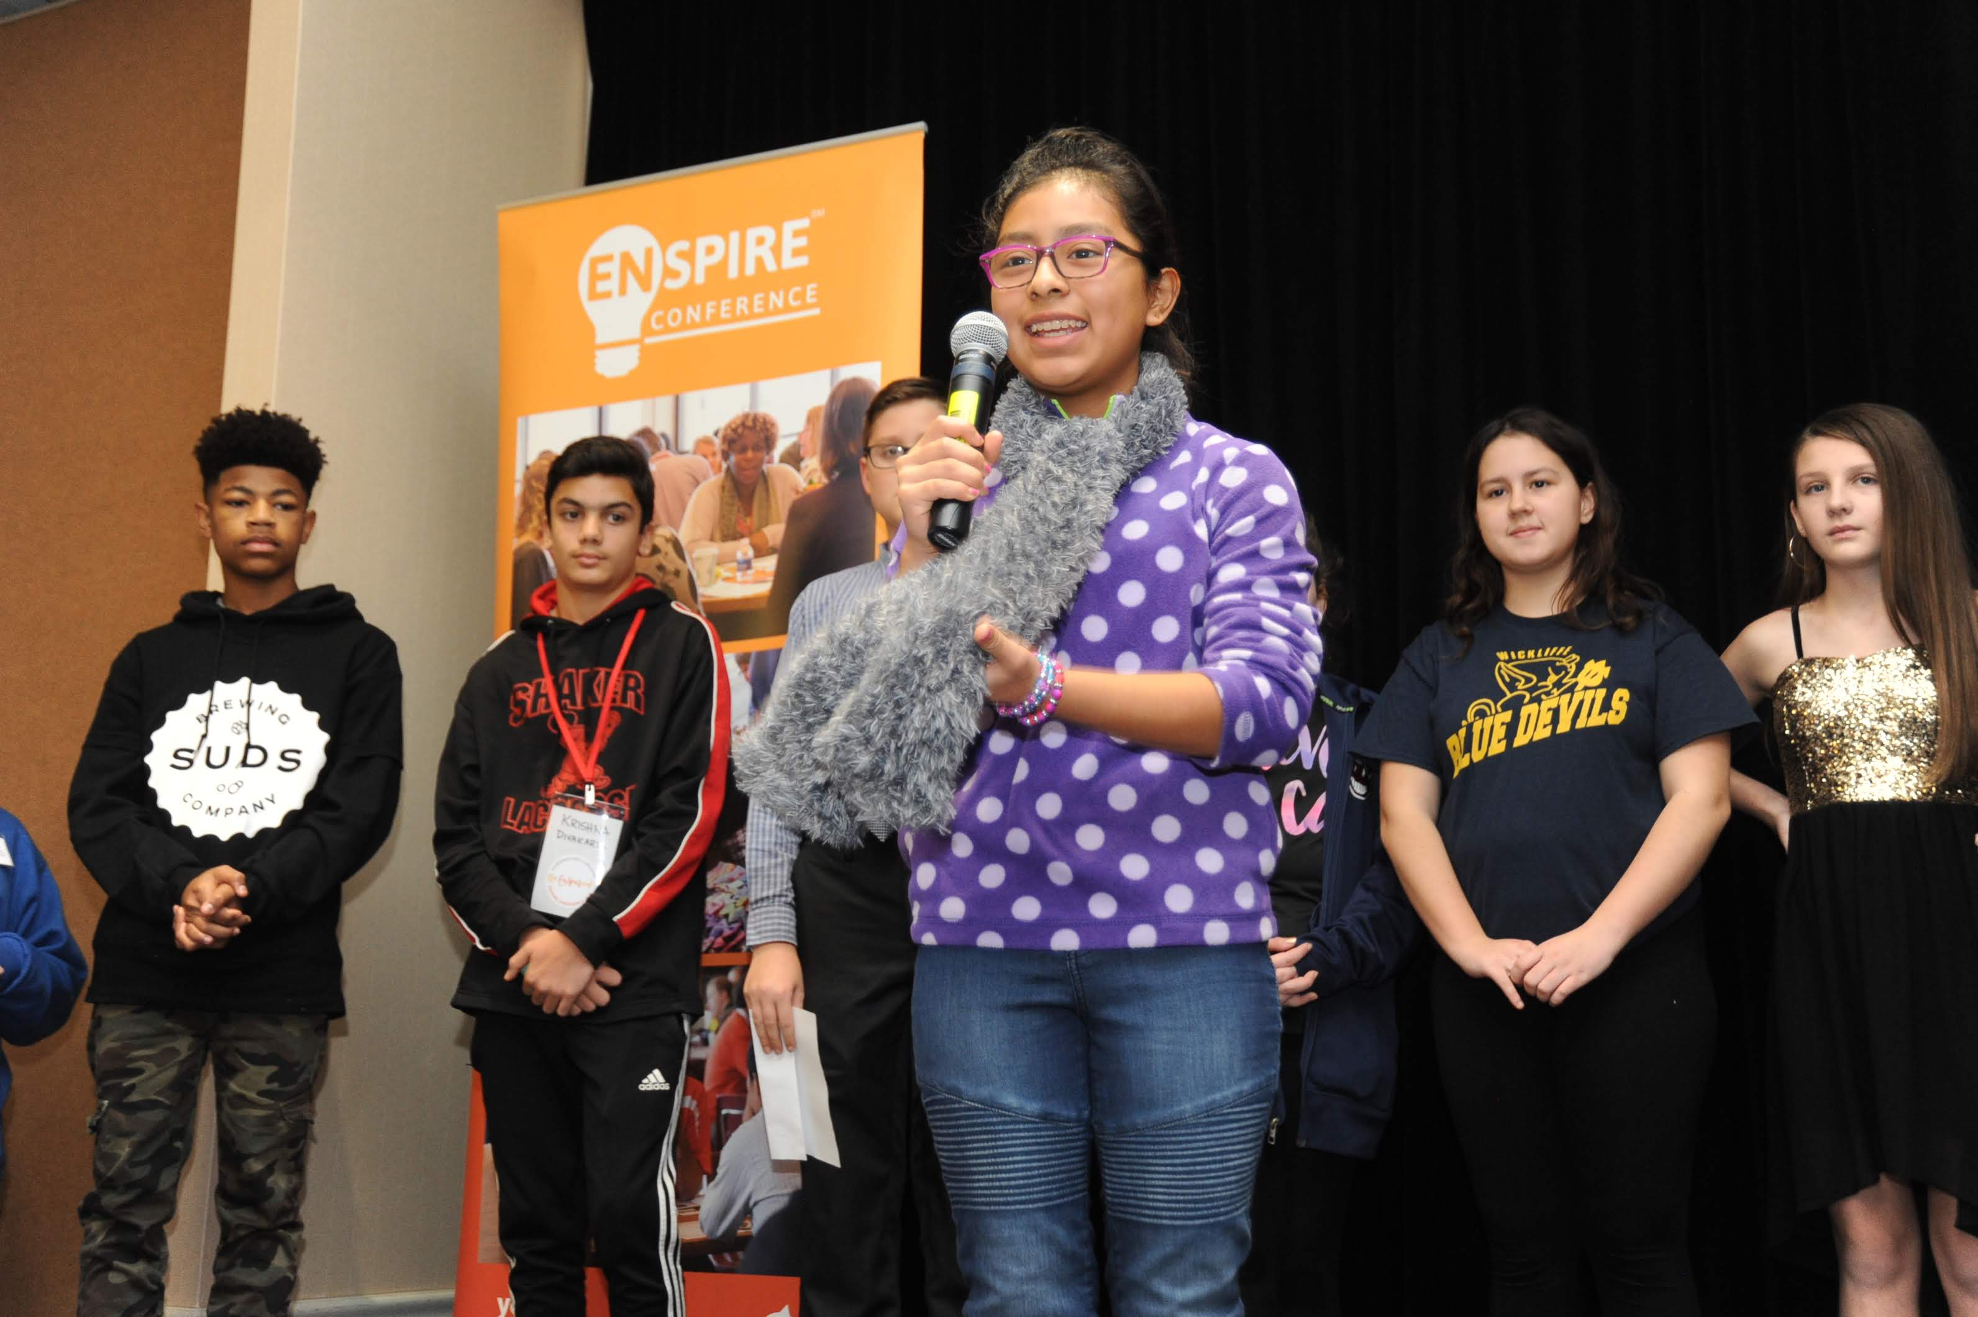
Young Entrepreneur Institute was founded by Greg Malkin in 2005 and launched its initial activities at University School in 2006. A successful serial entrepreneur himself for more than 30 years, Greg believes that future generations’ success rests with experiencing entrepreneurship early in life. He believes that entrepreneurship education and experience can make subjects such as math and writing more relevant to students.
Northeast Ohio is fortunate to have one of the strongest youth entrepreneurial ecosystems in the country. Young Entrepreneur Institute helps schools, community organizations and the northeast Ohio business community work together to develop and deliver programs that continuously strengthen entrepreneurial education and entrepreneurship experiences for young people.

Children

Young Entrepreneur Institute has impacted 10,000 students through programming, curriculum and our network of teachers and content providers. At Young Entrepreneur Institute, we believe that every child should understand and experience entrepreneurship. When children learn the tangible and intangible lessons of entrepreneurship early in life, they can see how the real world works. And by experiencing these universal lessons — such as perseverance, hard work, self-confidence, financial literacy, and problem solving – students are more prepared to succeed in whatever they choose to do. Our vision is to see that these lessons are instilled in as many students as possible.

